Logan staley 1988443 Assignment_2

Exercise 3.3 Consider the hat matrix H = X(X"X) - XT, where X is an N by d +1 matrix, and XTX is invertible. (a) Show that H is symmetric. (b) Show that HK = H for any positive integer K. (c) If I is the identity matrix of size N. show that (I-H)* = 1 - H for any positive integer K. (d) Show that trace(H) = d+ 1, where the trace is the sum of diagonal elements. (Hint: trace(AB) = trace(BA).]

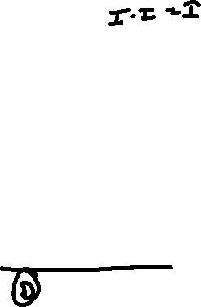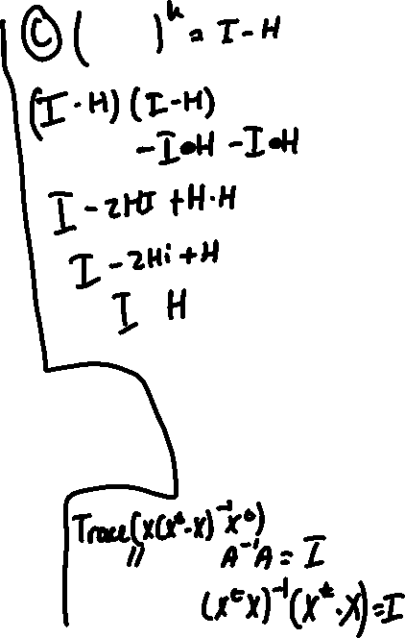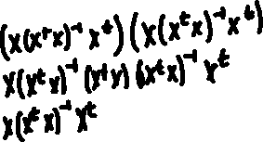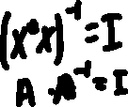

1. Another popular soft threshold is the hyperbolic tangent: tanh(s) = es - e-s es te-s? 1 How is tanh related to the logistic function? Show that tanh(s) converges to a hard threshold for large [s, and converges to no threshold for small |sl.

